Introduction
This user guide describes the Digilent AXI I2S Intellectual Property. The purpose of this IP is to implement an interface between an audio codec capable of I2S communication and a processor via the AXI4-Lite interface. For more high-speed and bulk data transfers it also features a AXI4-Stream interface.
IP quick facts
Supported device families | Zynq®-7000, 7 series
Supported user interfaces | Xilinx: AXI4 Lite, AXI4 Stream  Philips : I2S
Provided with core
Design files | VHDL
Simulation model | N/A
Constraints file | XDC
Software driver | Standalone
Tested design flows
Design entry | Vivado™ Design Suite 2016.4
Synthesis | Vivado Synthesis 2016.4

Features
- Internal MCLK generator at 12,228MHz
- Fixed 24-bit audio data width
- 7 sampling rate options
- Usable with AXI DMA

Performance
The IP manages audio samples on the I2S bus in both record and playback modes. It is capable of a full-duplex communication on the bus and can be used on codecs with which have a single or double LRCLK signal. Although many Audio codecs support different types of transfer modes this audio core can only transmit in I2S mode which means that the of the 32-bit data which is sent through the I2S bus the first byte is 0. Samples can be acquired by the processor via the AXI4-Lite bus for a slower and resource demanding project or can be written directly to the memory using a DMA on AXI4-Stream for a faster transfer rate.
The AXI4 Stream interface implemented by the IP is comprised of a 32bit wide TDATA bus, 4bit TKEEP bus and the TREADY, TVALID and TLAST signals.

Overview
The IP consists of several individual modules as can be seen in Figure 1, the FIFOs are used for the synchronization between the AXI4 clock and the I2S CTL clock which is 12, 288MHz. Both the AXI4-Lite and AXI4-Stream interface have access to the FIFOs but not simultaneously, if AXI4-Stream is active it will have priority control over the FIFOs. AXI4-Lite interface also provides control over the I2S CTL block trough registers, when using the IP core with either AXI4-Lite or AXI4-Stream the user must enable the I2S CTL block and must set the different parameters of the IP core for it to function properly.
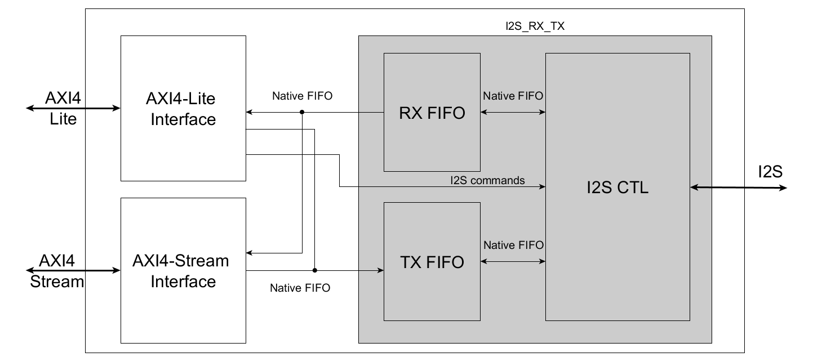
Figure 1. Digilent AXI I2S block diagram.

  - Configuring the IP
Some configuration option which are specific to the IP can be set in “Customize block”. Figure 2 show the customizable interface:
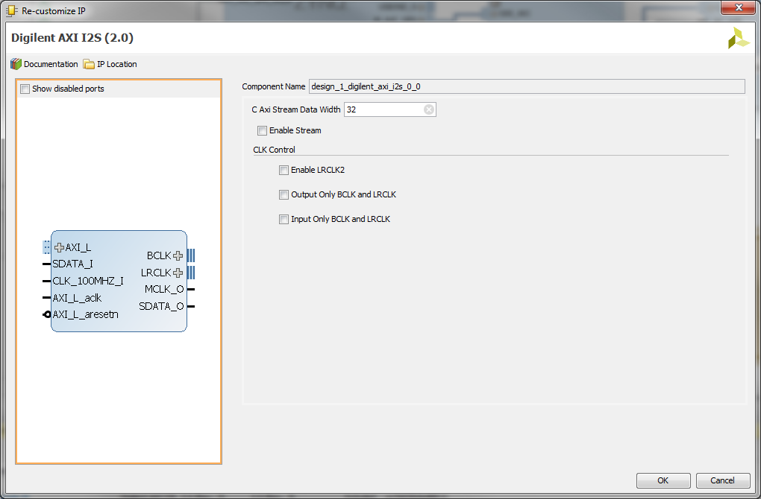
Figure 2. IP customization
C Axi Stream Data Width allows the user to change the data with of the stream interface, by default the value is 32 bits same as the AXI4-Lite interface.
By default, the Stream interface for the IP is disabled by checking the Enable Stream box the AXI4-Stream interface becomes active and can be used with the AXI DMA for bulk transfers.
Some audio codecs use to asynchronous LRCLKs for the I2S interface, this IP core can enable a second LRCLK port by checking the Enable LRCLK2 box. The two LRCLK ports of the I2S are synchronous to each other. This option works only in Output only BCLK and LRCLK mode.
The user can choose to wheatear to use IP in slave mode or in master, by default master should be chosen. When in master mode the I2S signals are outputs so Output only BCLK and LRCLK should be selected; in slave mode Input only BCLK and LRCLK must be active.

  - AXI4 Lite registers
The AXI I2S core implements control and status registers. Each register is described as follows.
Address Space Offset | Name | Description
00h | Global reset | AXI I2S global reset for all modules
04h | Transfer control | I2S control register
08h | FIFO control | Controls both the RX_FIFO and the TX_FIFO
0Ch | Data in | Sample sending register (disabled in stream mode)
10h | Data out | Sample acquisition register (disabled in stream mode)
14h | Status | RX_FIFO and TX_FIFO status register
18h | Sampling rate | Sets the sampling rate of the I2S IP core
1Ch | Length | Number of samples to be sent over AXI4-Stream (used only in stream mode)
20h | Stream control | Register to control the stream interface (used only in stream mode)
Table 1. AXI4 Lite register space

register
Rx Control Bit
Tx Control Bit

Length register

Length [22:0]

register
Tx Status Bit
Rx Status Bit
Global reset registers (I2S_RESET_REG) 0x00
31 Reserved 1 | 0

This register is used to reset the whole core and all its components.
Bits | Field Name | Default value | Access Type | Description
31:1 | Reserved | N/A | N/A
0 | I2S_RST_I | 0 | R/W | Is the master reset signal for the IP core. This will reset the whole system and keep it in reset until a 0 value is written to it.

Transfer control register (I2S_TRANSFER_CONTROL_REG) 0x04
31 Reserved 2 | 1 | 0

Enables the transmission of data on the I2S bus. The channels are independent and can be uses to start the transmission or the reception of data. They however don not load the data in the data registers.
Bits | Field Name | Default value | Access Type | Description
31:2 | Reserved | N/A | N/A
1 | RX_RS_I | 0 | R/W | Is the enable pin for the Data reception on the I2S bus. This is directly connected to the LRCK and BLCK signals and the RX_FIFO write enable
0 | TX_RS_I | 0 | R/W | Is the enable pin for the Data transmission on the I2S bus. This is directly connected to the LRClK and BLCK signals and the TX_FIFO read enable

FIFO control register (I2S_FIFO_CONTROL_REG) 0x08
31 | 30 | 29 Reserved 2 | 1 | 0

Used to control the read and write enable of the reception and transmission FIFOs. It also has the capability to reset the individual FIFOs to clear all the stored samples
Bits | Field Name | Default value | Access Type | Description
31 | RX_FIFO_RST_I | 0 | R/W | Resets the RX_FIFO and deletes all the stored samples in it. Stays in reset until a 0 is written.
30 | TX_FIFO_RST_I | 0 | R/W | Resets the TX_FIFO and deletes all the stored samples in it. Stays in reset until a 0 is written.
29:2 | Reserved | N/A | N/A
1 | RX_FIFO_RD_EN_I | 0 | R/W | Enables the read function of the RX_FIFO and loads the acquired sample in to the Sample acquire register. This has no functionality when the stream capabilities are enabled.
0 | TX_FIFO_WR_EN_I | 0 | R/W | Enables the write function of the TX_FIFO and loads the desired sample in to the FIFO from the Sample sending register. This has no functionality when the stream capabilities are enabled.

Data In register (I2S_DATA_IN_REG) 0x0C
31 |  | 0

Contains the samples which will be sent to the transmission FIFO; this register is inactive when AXI4-Stream is used because all the samples will be transmitted through the AXI4-Stream directly to the FIFO.
Bits | Field Name | Default value | Access Type | Description
31:0 | I2S_DATA_IN_REG | 0 | W | Contains the loaded sample from the processing unit which will be transmitted when the TX_FIFO_WR_EN_I is set. In Stream mode all the sample come directly from the DDR memory therefore this is inactive.

Data Out register (I2S_DATA_OUT_REG) 0x10
31 |  | 0

Contains the acquired word from the I2S through the FIFO; this register is inactive when AXI4-Stream is used because all the samples are directly recorder in to the DDR.
Bits | Field Name | Default value | Access Type | Description
31:0 | I2S_DATA_OUT_REG | 0 | R | Contains the data which has been acquired by the I2S bus. The register is loaded when RX_FIFO_RD_EN_I is set. In stream mode all the samples are directly written in to the DDR through the AXI4-Stream interface.

Status register (I2S_STATUS_REG) 0x14
31 Reserved 18 | 17 | 16 | 15 Reserved 2 | 1 | 0

The status register monitors the status of the FIFO flags. These flags are necessary in non-stream mode to ensure that the FIFOs are not full or empty and data can still be acquired or transmitted.
Bits | Field Name | Default value | Access Type | Description
31:18 | Reserved | N/A | N/A
17 | RX_FIFO_FULL_O | 0 | R | Represents the full flag of the acquisition register
16 | RX_FIFO_EMPTY_O | 1 | R | Represents the empty flag of the acquisition register
15:2 | Reserved | N/A | N/A
1 | TX_FIFO_FULL_O | 0 | R | Represents the full flag of the transmission register
0 | TX_FIFO_EMPTY_O | 1 | R | Represents the empty flag of the transmission register

Sampling rate register (I2S_CLOCK_CONTROL_REG) 0x18
31 Reserved 17 | 16 | 15 Reserved 4 | 3 | 2 | 1 | 0

Determines if the core is either in slave or in master mode and sets the division ratio of the BCLK and LRCLK according to the chosen sampling frequency.
Bits | Field Name | Default value | Access Type | Description
31:17 | Reserved | N/A | N/A
16 | CTL_MASTER_MODE_I | 0 | R/W | Sets the I2S core in to slave mode which means that the LRCLK and BCLK signals are generated by the codec.
15:4 | Reserved | N/A | N/A
3:0 | SAMPLING_RATE_I | 0 | R/W | Set the division rate of the MCLCK in accordance to the Sampling rate of the codec. This sampling rate is coded as follows:  0 - 8 kHz  1 - 12 kHz  2 - 16 kHz  3 - 24 kHz  4 - 32 kHz  5 - 48 kHz  6 - 96 kHz

Length register (I2S_PERIOD_COUNT_REG) 0x1C
31 |  |  |  |  | Reserved |  |  |  |  | 21 | 20 |  |  |  |  |  |  |  |  |  |  |  |  |  |  |  |  |  |  |  | 0

The register is used to indicate the number of sample words which will be either read or written using the AXI4-Stream to the DMA and subsequently to the DDR. This register can be ignored when the stream capabilities of the core are not used.
Bits | Field Name | Default value | Access Type | Description
31:21 | Reserved | N/A | N/A
20:0 | NR_OF_SMPL_I | 0 | R/W | Represents the number of samples the AXI4-Stream protocol will transfer. These samples are used for both the channels of the stream. The register is not used when in non-stream mode

Stream control register (I2S_STREAM_CONTROL_REG) 0x20
31 Reserved 2 | 1 | 0

This register is used to enable or disable the AXI4-Stream capabilities of the core. When either of the two enable bits is active the I2S core is consider being in stream mode.
Bits | Field Name | Default value | Access Type | Description
31:2 | Reserved | N/A | N/A
1 | RX_STREAM_EN_I | 0 | R/W | Enables the pin to control the transmission of the AXI4-Stream channel. When this is active the core is set in to stream mode.
0 | TX_STREAM_EN_I | 0 | R/W | Enables the pin to control the reception of the AXI4-Stream channel. When this is active the core is set in to stream mode.

- Port descriptions
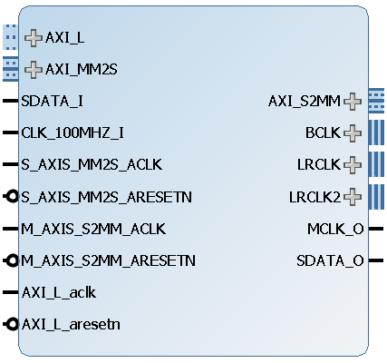
Figure 3. AXI I2S IP Core.
The table below will present the signals and interfaces implemented by the AXI I2S core.
Signal Name | Interface | Signal Type |  |  |  | Init State | Description
SDATA_I | I2S | Input |  |  |  | N/A | Data samples provided by audio codec trough the I2S interface
BCLK | I2S | Input / Output |  |  |  | N/A | Bit clock
LRCLK | I2S | Input / Output |  |  |  | N/A | Left/Right channel clock
LRCLK2 (optional) | I2S | Input / Output |  |  |  | N/A | Left/Right channel clock for codecs that require two LRCLK
MCLK_O | I2S | Output |  |  |  | N/A | Master clock output towards the audio codec 12.228 MHz
SDATA_O | I2S | Output |  |  |  | N/A | Write signal. When low, data byte is valid.
CLK_100MHZ_I | - | Input |  |  |  | N/A | 100 MHz clock that must be provided by the user, for the IP to work properly
M_AXIS_S2MM_ACLK | MM2S | Input |  |  |  | N/A | MM2S interface clock signal
S_AXIS_MM2S_ACLK | S2MM | Input |  |  |  | N/A | S2MM interface clock signal
AXI_L_aclk | AXI_LITE | Input |  |  |  | N/A | AXI_LITE interface clock signal
M_AXIS_S2MM_ARESETN | MM2S | Input |  |  |  | N/A | M2SS
S_AXIS_MM2S_ARESETN | S2MM | Input |  |  |  | N/A | S2MM reset signal
AXI_L_aresetn | AXI_LITE | Input |  |  |  | N/A | AXI_LITE reset signal
AXI4 Lite Interface Signals
AXI_LITE* |  |  | Input / Output | AXI4 Lite interface used to communicate with the control and status registers
AXI4 Stream Interface Signals
S2MM* |  |  | Input |  | AXI4 Stream interface - input for data which will be converted to the I2S protocol
MM2S* |  |  | Output |  | AXI4 Stream interface - output for data which has been received from the I2S port
Table 2. Port descriptions

Designing with the core

Constraints
The AXI I2S core includes the timing constraints needed for the I2S protocol for cross domain clocking between the processor and the audio codec.

Using the AXI I2S
When using the IP core in either AXI4-Lite only or in AXI4-Stream mode some registers must be set which are common to both modes. The user must make sure that I2S controller is enabled in the desired direction, RX_RS_I for receiving and TX_RS_I for sending audio samples, which can be found in the transfer control register. A second requirement is that the desired sampling rate and the master/slave mode must be set in the sampling rate register, the recommended settings for this register is 48KHz sampling rate and CTL_MASTER_MODE_I to 0. When using the IP in either AXI4-Lite mode or AXI4-Stream mode there are some options which are specific to these operation modes and must be set accordingly.
When using only AXI4-Lite to receive samples the user must check the RX_FIFO_EMPTY_O in the status register. If the RX_FIFO_EMPTY_O bit is not set, it means that there are samples stored in the RX_FIFO which can be loaded in to the data in register and can be passed on to the processor. Samples are loaded in to the data in register by setting the RX_FIFO_RD_EN_I bit in the FIFO control register; this bit must be cleared immediately after it has been set to make sure that only one sample has been loaded in to the data in register.
Sending samples using the AXI4-Lite interface is done using the data out register. When sending samples, the TX_FIFO_FULL_O bit in the status register must be monitored, if the bit is cleared samples can be sent without losing any data. Samples are loaded in to the TX_FIFO using the TX_FIFO_WR_EN_I bit in the FIFO control register; this bit must be cleared immediately after it has been set to make sure that only one sample has been loaded in to the data out register.
When using the AXI4-Stream interface the data in and data out registers can no longer be used to manage samples. The stream interface manages automatically the writing and reading of the FIFOs until the predefined number of samples are recorded or played back. To read or write data samples first the length register must be initialized with the desired number of samples which will be transferred. The length register is used for both the recording and the playback operation and is read out by the IP core when wither RX_STREAM_EN_I or TX_STREAM_EN_I is set. After setting the length register the user can either record samples by setting the RX_STREAM_EN_I bit, in the stream control register, or can playback samples by setting the TX_STREAM_EN_I bit in the same register. The AXI I2S core can operate in full duplex on the AXI4-Stream interface, which enables the it to record and playback at the same time.

AXI I2S Driver
From the software perspective, the I2S core has a driver which can be easily interfaced with the MicroBlaze soft-core processor or the AMR of the Zynq. The driver has been build following Xilinx driver structure and can be easily accessed and used to set or clear the different bits of the control registers. It is also designed to have several defined functions which will simplify the access to the core for the user. All the functions in the driver have the prefix DI2s_ to ensure no overlapping of any functions that might have similar names in the project and to easily associate the function to the specific driver.

The source file structure is as follows:
di2s_l.h – contains the low level definition such as the register space, bit position of every signal and the bit-field structure in order to manipulate the bits in the registers.
di2s_i.h – is a header file designed for internal use of the driver, the user will not have access to this file
di2s_g.c – Xilinx uses this file in order to generate a table of core instances with some configuration parameters. These tables are generally automatically created, but this file was created manually and should be edited in order to be kept up to date. This is because the automatic .tcl script is missing from the hardware design
di2s_sinit.c – file used in order to configure and initiate the device instance; is called from di2s.c
di2s.h – is the main header file of the driver. It contains the function prototypes of the driver and some variable definition which allow an easier access to the configuration settings.
di2s.c – is the main .c file which contains all the function definitions used by the driver.
The driver is designed as an aid for users who want to use the core, making it an optimal tool to avoid any low level configurations. It also has to be manually configured by changing the configuration definitions of the di2s_l.h, such as DI2S_STREAM_ENABLE, DI2S_MASTER and DI2S_DMA_CAPABLE. In order to simplify the setting and clearing of registers bits a bit-filed has been employed. The bit-field variable is called DI2s_BitField and is utilized throughout the whole driver and is set and reset many times.
DI2S_DMA_CAPABLE also activates some functions which are required for the DMA transfer in order to work properly. If DI2S_DMA_CAPABLE is not defined, these functions and any DMA capabilities are not utilized.
The function list of the higher level driver which is recommended to be used is as follows:
Function name | Description
DI2s_Initialize(DI2s *) | This function is used in order to set the configuration and the base address of the core to the instance pointer. Returns successful or fail status.
DI2s_CfgInitialize(DI2s *, DI2s_Config *, u32) | Called automatically by DI2s_Initialize in order to pass the configuration options from the configuration table to the instance pointer. Returns successful or fail status.
DI2s_ReadStatusReg(DI2s *) | Reads out the status register and returns the whole register.
DI2s_GetTxFifoEmpty(DI2s *) | Reads out the TX FIFO empty flag from the status register and returns the value.
DI2s_GetTxFifoFull(DI2s *) | Reads out the TX FIFO full flag from the status register and returns the value.
DI2s_GetRxFifoEmpty(DI2s *) | Reads out the RX FIFO empty flag from the status register and returns the value.
DI2s_GetRxFifoFull(DI2s *) | Reads out the RX FIFO full flag from the status register and returns the value.
DI2s_GetSample(DI2s *) | Reads and returns the current value stored in the I2S_DATA_IN_REG register.
DI2s_SendSample(DI2s *, u32) | Writes a sample value to the I2S_DATA_OUT_REG register, which will be sent to the I2S bus.
DI2s_Reset(DI2s *) | Resets the whole core
DI2s_StartI2s(DI2s *, u8) | Starts the I2s bus transactions in on direction depending on the direction bit which can be found in di2s.h file
DI2s_StopI2s(DI2s *, u8) | Stops the I2s bus transactions in on direction depending on the direction bit which can be found in di2s.h file
DI2s_SetClockOptions(DI2s *, u8, u8) | Sets the clocking options for the core, its parameters are the clocking frequency and the slave mode select bit. The clocking frequencies can be found in di2s.h and the slave bit depends on the configuration of the hardware core.
DI2s_SimpleRecord(DI2s *, u32, u32) | Function is used in order to record samples through the AXI4-Lite interface; it receives as parameters the number of samples and the address in the memory where to record. It also utilizes some of the previously defined functions
DI2s_SimplePlayBack(DI2s *, u32, u32) | Function is used in order to play back samples through the AXI4-Lite interface; it receives as parameters the number of samples and the address in the memory where to record. It also utilizes some of the previously defined functions
DI2s_SetNrSamples(DI2s *, u32) | Sets the sample transfers register counter to a certain value. This function is only active if DI2S_DMA_CAPABLE is defined
DI2s_DmaRecord(DI2s *, XAxiDma *, u32, u32) | Function is used in order to record samples through the AXI4-Stream interface; it receives as parameters he DAM instance, the number of samples and the address in the memory where to record. It also utilizes some of the previously defined functions. This function is only active if DI2S_DMA_CAPABLE is defined.
DI2s_DmaPlayBack(DI2s *, XAxiDma *, u32, u32) | Function is used in order to record samples through the AXI4-Stream interface; it receives as parameters he DAM instance, the number of samples and the address in the memory where to record. It also utilizes some of the previously defined functions. This function is only active if DI2S_DMA_CAPABLE is defined.

When using the AXI I2S core in stream mode with the provided driver, the user must manually define the DI2S_DMA_CAPABLE and set the DI2S_STREAM_ENABLE to 1 in the di2s_l.h. The functions for setting up the AXI DMA are not provided and should be written by the user.

- References
The following documents provide additional information on the subjects discussed:
- Xilinx Inc., UG471: 7 Series FPGAs SelectIO Resources, v1.4, May 13, 2014.
- Xilinx Inc., UG472: 7 Series FPGAs Clocking Resources, v1.6, October 2, 2012.
- Xilinx Inc., UG903: Using Constraints, v2014.3, October 31, 2014
- Xilinx Inc., PG021: AXI DMA logiCORE IP Product Gudie, v7.1, november 18, 2015
- Analog Devices, ADAU1761: SigmaDSP Stereo, Low Power, 96 kHz, 24-Bit Audio Codec with Integrated PLL, Rev. C
- Analog Devices, SSM2603: Low Power Audio Codec, Rev. B

